**VYSYARAJU BHAVYA**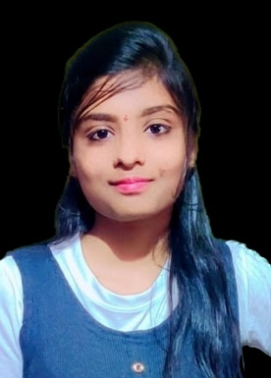

**Email :** vysyarajubhavya@gmail.com

**Contact** : +91-7989226518

**LinkedIn** : https://www.linkedin.com/in/ bhavya-vysyaraju-963948281

**OBJECTIVE**

**Seeking a position in the field of Computer Science where I can utilize my skills to further work towards personal and professional development and contribute towards the prosperity of the organization.To work as a (job role being offered) in your progressive organization that allows me the scope to update my knowledge to the latest trends and be part of a diverse and dynamic team that adds to both my personal and professional growth**

**ACADEMIC QUALIFICATIONS**

|  |  |  |  |
| --- | --- | --- | --- |
| Academic Qualification | University/Board | Year | Percentage /CGPA |
| B.Tech. (IT) | JNTUK | 2021 | 9.12 CGPA |
| Intermediate | Board of Intermediate Education, AP | 2017 | 9.1 |
| SSC | Board of Secondary Education, AP | 2015 | 9.8 |

**TECHNICAL SKILLS**

**Programming :** Python, Java, C++

**Development :** HTML, CSS

**Database :** MySQL

**PROJECT EXPERIENCE**

**MASS-MAILDISPATCHER**

A mass mail dispatcher is a tool or software used to send bulk mails to a large number of recipients simultaneously.

**INTERNSHIP EXPERIENCE**

**WEB DEVLOPMENT**

**Organization :** Exposys data labs.

This promotes working with web applications development.

**CERTIFICATIONS**

**BASICS OF PYTHON CERTIFICATION**

Issued by : Infosys | Springboard

**JAVA LANGUAGE FEATURES**

Issued by : Infosys | Springboard

**CO CURRICULAR ACTIVITIES**

* Participated in Django Workshop Organized by APSSDC.
* Participated in Data Analysis Using python Organized by APSSDC.
* Completed a course on programming using cpp provided by Infosys springboard.

**EXTRA CURRICULAR ACTIVITIES**

* Performing arts.
* Participated in various activities such as quizzes,sports,etc.
* An active member of NSS.

**PERSONAL DETAILS**

**Father Name : vysyaraju.Ramesh raju**

**Date of Birth : 20th December 2003**

**Languages Known : English, Telugu**

**Hobbies/Interests : listening music,painting**

**Address : D/no- 14-1-229,palasa(Mandal), Srikakulam (District),**

**Andhra Pradesh (State), Pin code: 532222.**

**Date:** 04/07/2023 (VYSYARAJU BHAVYA)

**Place:** Tekkali Signature